How to add postcode search function to IVMS Client side
1. First, make sure your client is get map from your server side, you can check it as below.
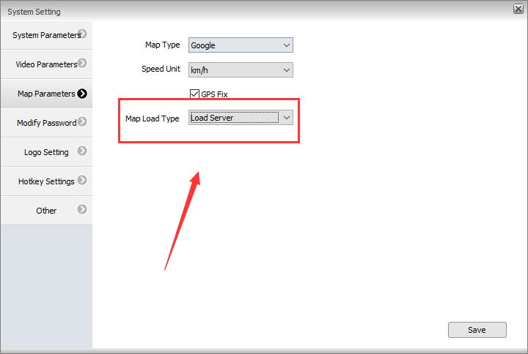
2. Download the new map file from below link:
https://www.dropbox.com/s/rgrj7f6u7x5nip9/Map-PostCode-202006171616.zip?dl=0
3. Decompress the downloaded file, then copy it to this path, you just need to overwrite the old file.
P.S.: Before updating the file, please backup your old map file first.
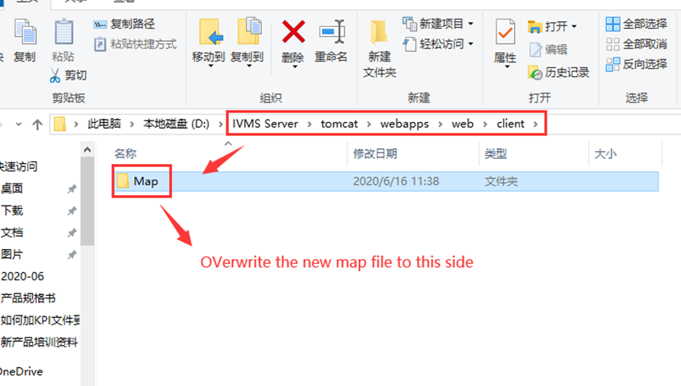
4. Open this path, then add your Google Map API Key to gmap.html file as below:
Such as: <script type=text/javascript src="http://maps.google.com/maps/api/js?key=AIzaSyBddRP0rnhARUHJkjxIXcH6CzE4k12345&sensor=false&libraries=places" charset="utf-8"></script>
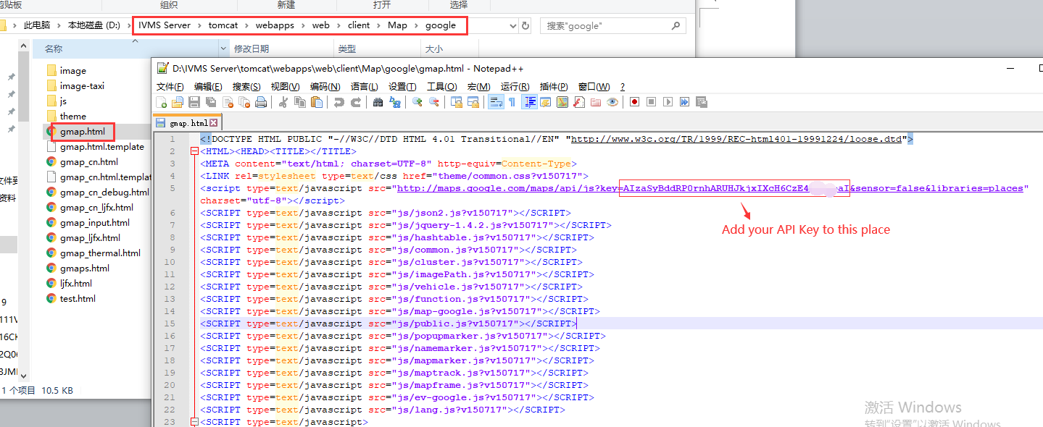
4. Restart your web server, then use the account login IVMS Client, you will find it has postcode search function now.
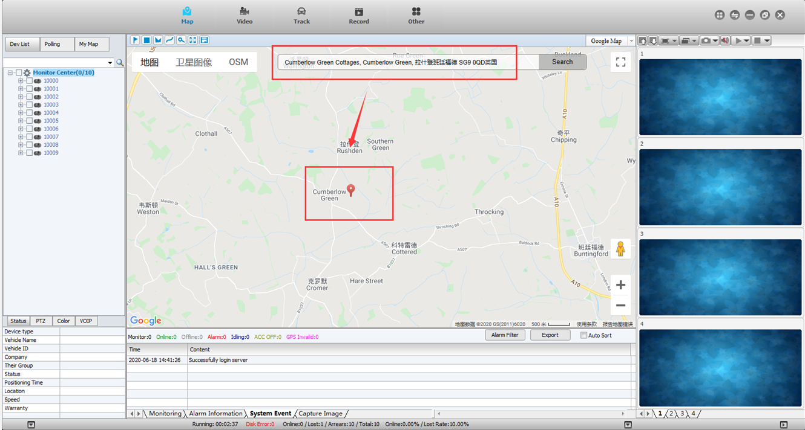
Notice：If it does not work, then please clean your IE browser cache and try again.

